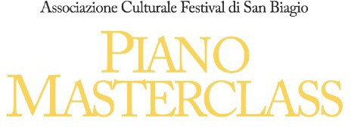

26th-29th august 2024

Registration form for the Masterclass and the Association I, the undersigned

Name Surname

born in data Address Postal Code City State Nationality Tel. Cell. Code Fiscal E-mail Registration for the Masterclass with the teacher

The registration fee of €120 must be paid to the following bank account headed to: Associazione Culturale Festival di San Biagio. IBAN: **IT93L0570438470000000151500** BANCO DESIO, Reason: Masterclass Schmidt and sent a copy of the payment and registration to the course at: [festivalsanbiagiodirezioneart@gmail.com](mailto:festivalsanbiagiodirezioneart@gmail.com)

Asks to be admitted as an ORDINARY member of the association, for the performance and achievement of the primary purposes of the same, following the articles of association and the resolutions of the corporate bodies, as well as to pay the social party. Declares to have taken note of the Statute (and any Rules) and accept them in full. Upon receipt of the information on the use of personal data pursuant to Legislative Decree no.196/03.

I consent to their processing to the extent necessary for the pursuit of the purposes of the state. I also agree that the data concerning the registration are communicated to the bodies with which the association cooperates and by these treaties to the extent necessary for the fulfilment of obligations provided by law and by the statutory rules. Absolutely free from stamp - art. 7 - Table - annex B - D.P.R. 26.10.1972 n. 642

(legible signature; for the minor, signature of the person exercising parental authority)

Date